
NAME: RACHITHA.R
REG-NO: 192421058
SUBJECT: COMPUTER VISION FOR IMAGE SEGMENTATION
SUBJECT-CODE: ITA0528
DATE: 28.02.2026
EXPERIEMNT – 16
Code:
import cv2
img = cv2.imread("sample.jpg")
gray = cv2.cvtColor(img, cv2.COLOR_BGR2GRAY)
sobelx = cv2.Sobel(gray, cv2.CV_64F, 1, 0, ksize=3)
sobely = cv2.Sobel(gray, cv2.CV_64F, 0, 1, ksize=3)
cv2.imshow("Sobel X", sobelx)
cv2.imshow("Sobel Y", sobely)
cv2.waitKey(0)
cv2.destroyAllWindows()
Output:
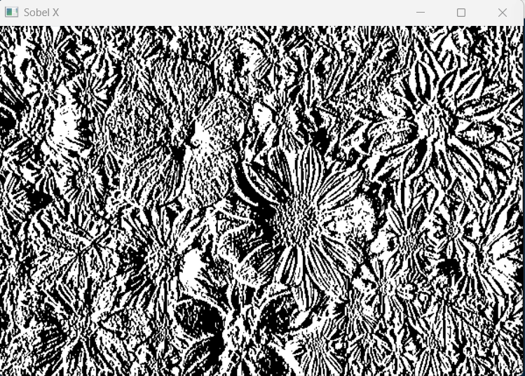

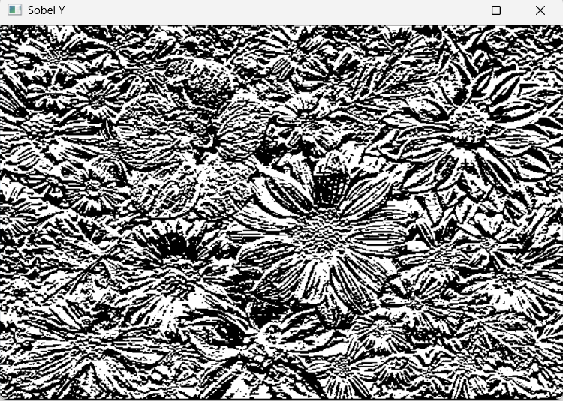
EXPERIMENT – 17
Code:
import cv2
img = cv2.imread("sample.jpg")
cv2.putText(img,"RACHITHA",(50,50),cv2.FONT_HERSHEY_SIMPLEX,1,(0,0,255),2)
cv2.imshow("Watermarked Image",img)
cv2.waitKey(0)
cv2.destroyAllWindows()
Output:
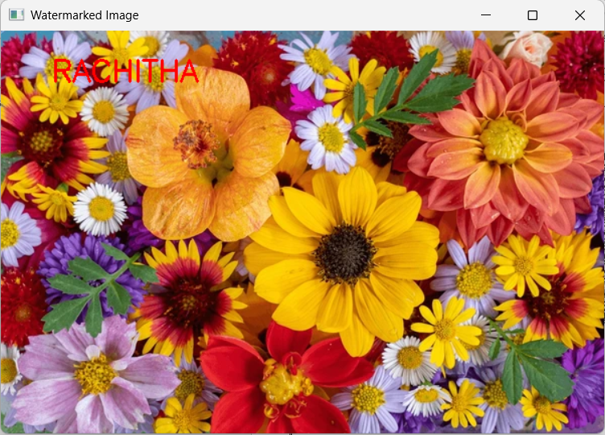

EXPERIMENT – 18
Code:
import cv2
img = cv2.imread("sample.jpg")
roi = img[100:300, 200:400]
img[0:200, 0:200] = roi
cv2.imshow("Modified Image", img)
cv2.waitKey(0)
cv2.destroyAllWindows()
Output:
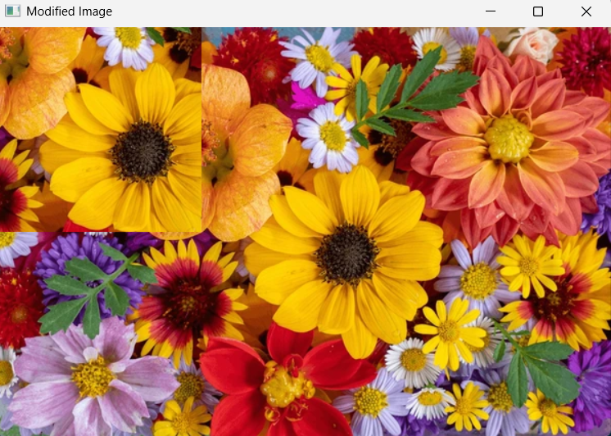

EXPERIMENT – 19
Code:
import cv2
import numpy as np
img = cv2.imread("sample.jpg")
kernel = np.ones((5,5), np.uint8)
eroded = cv2.erode(img, kernel, iterations=1)
cv2.imshow("Original Image", img)
cv2.imshow("Eroded Image", eroded)
cv2.waitKey(0)
cv2.destroyAllWindows()
Output:
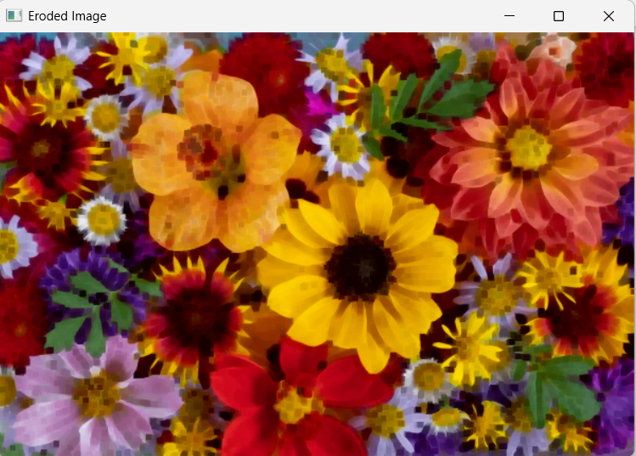

EXPERIMENT – 20
Code:
import cv2
import numpy as np
img = cv2.imread("sample.jpg")
kernel = np.ones((5,5), np.uint8)
dilated = cv2.dilate(img, kernel, iterations=1)
cv2.imshow("Original Image", img)
cv2.imshow("Dilated Image", dilated)
cv2.waitKey(0)
cv2.destroyAllWindows()
Output:
